**Chapter 2 – EXPRESS API LOG-IN AND DASBOARDS FUNCTIONALITY**

**-:Content:-**

* **INTRODUCTION**
* **Create loginControler.js file**
* **Create DashbordControler.js file**
* **Update Routes.js file**
* **Use postman to see the result**

**1. Introduction**

* In the previous lesson 1 we learn how create event and how to fetch a user details using the user id .After that we add two more file add on Controllers folder one is **LoginController.js** and another is **DashboardController.js.**
* **Following path:**

Src > Controllers > LoginContrellers.js

Src > Controllers > DashboardController.js

**2. Create LoginContrellers.js**

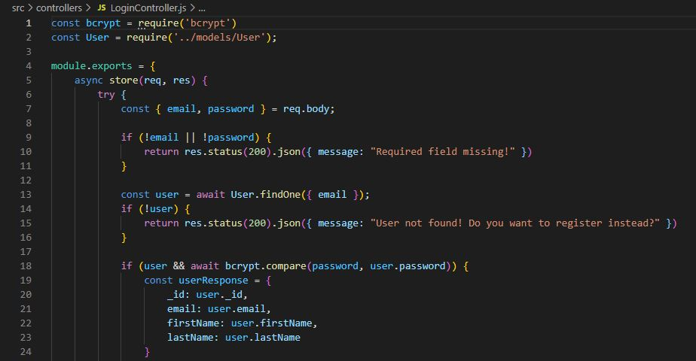

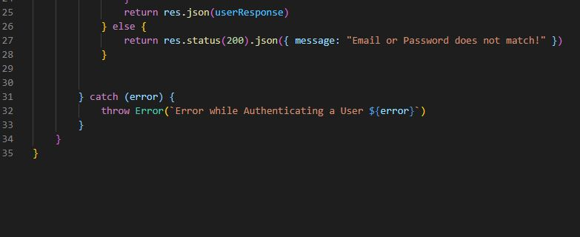

* **Explanation: -** In **loginController.js** file we are add some that’s use our email and password if the email is correct its matches the email or password and gave the user details. If any use gave wrong password then its show us email password doesn't match.

**3.** **Create DashboardController.js**

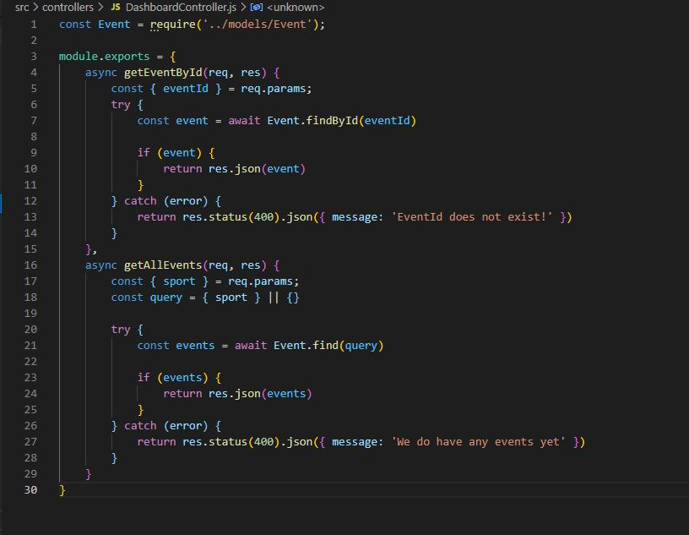

* **Explanation: -** In **DashboardController.js** we are use **GetEventById()** function that use a event_id and gave a result of those event.
* Another function **GetAllEvent()** it is provide all the event are in database and show the result in Dashboard.
* Using particular Sport name we can see the event on dashboard.

**4. Create routes.js**

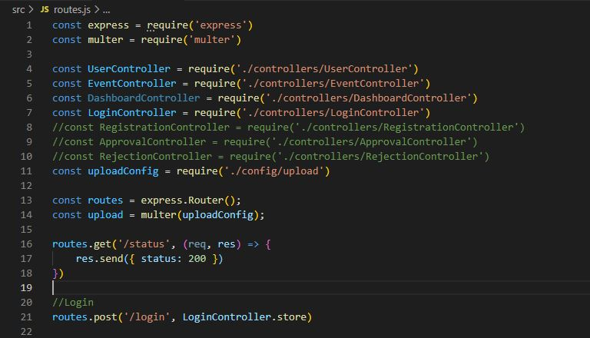

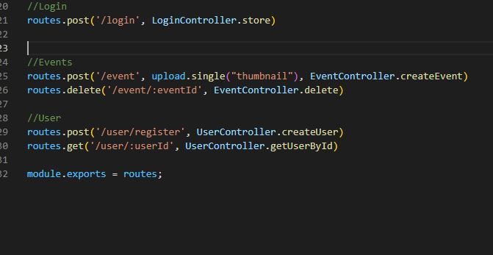

* **Explanation:-** **After Completing the All Controller File we are add those file in Routes.js. it is a middleware that’s can connect to the other controller file and helps for Connecting to Server.**

**5. POSTMAN**

**5.1 Use postman in login**

* Step 1 – For new request go to “+” icon and add a new request .
* Step 2 – Select method post and put localhost:8000/login
* Step 3 – Select Body and go to Row and select JSON and then go and type email and password as JSON format. Click on send and result is given bellow if exist or not then show password and email is wrong.

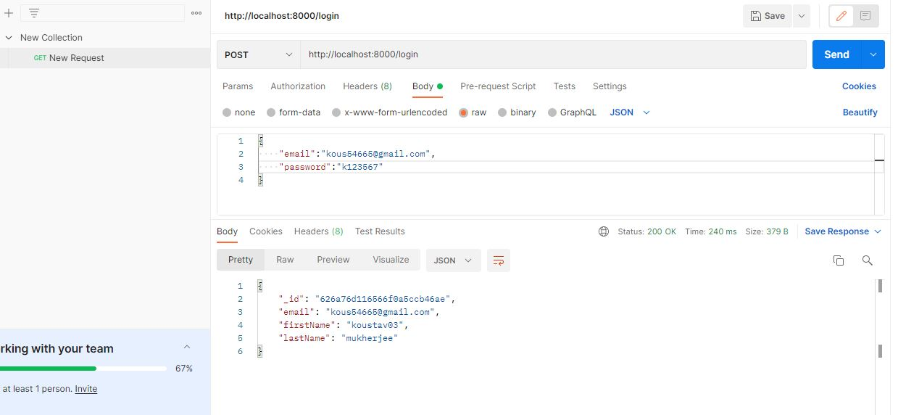

**5.2 Use postman in dashboard**

* In dashboard part then we use event_id and Findout the particular event
* In dashboard we put the /dashboard and see the result
* In dashboard we put the /dashboard/sport and see the events that are sport event.
* **Use postman in Dashboard(/dashboard)**

Step 1 – For new request go to “+” icon and add a new request .

Step 2 – Select method post and put **localhost:8000/dashboard**

Step 3 –Click on send and result is given bellow .

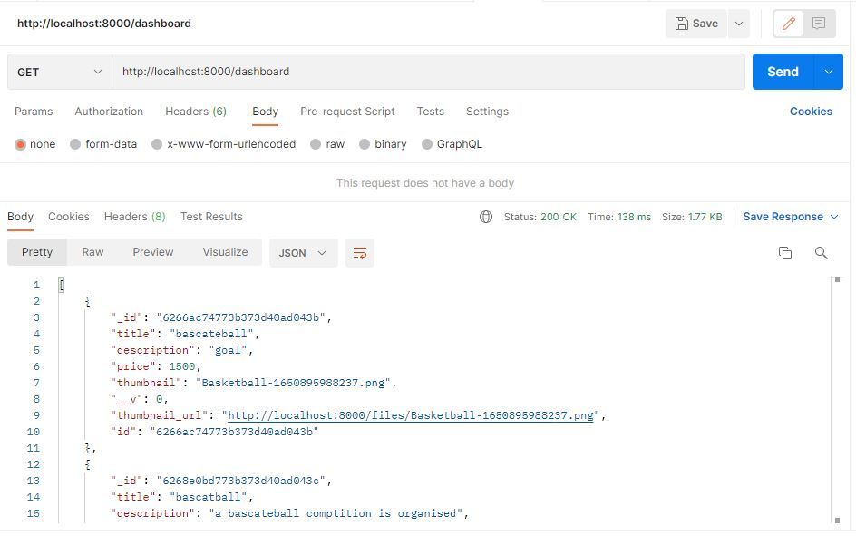

* **Use postman in Dashboard(sport)**

Step 1 – For new request go to “+” icon and add a new request .

Step 2 – Select method post and put localhost and then put the sport name like this **localhost:8000/dashboard/basketball**

Step 3 –Click on send and result is given bellow .

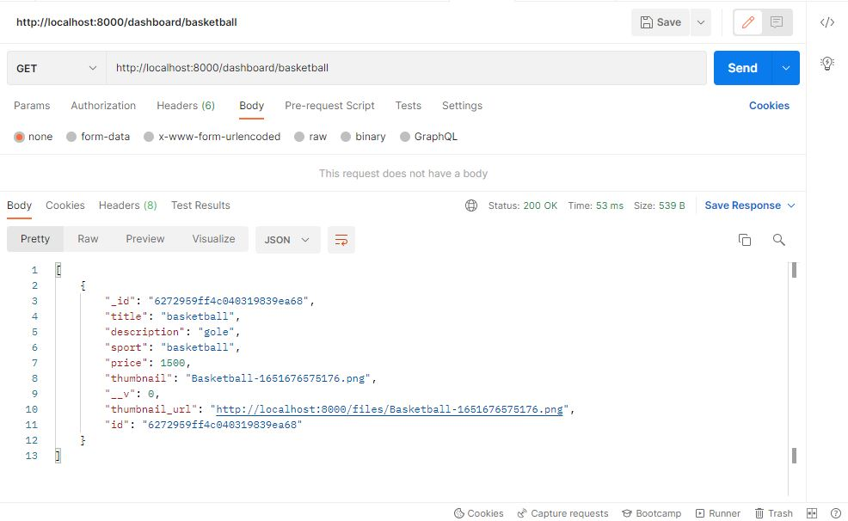

* **Use postman in Dashboard(event_id )**

Step 1 – For new request go to “+” icon and add a new request .

Step 2 – Select method post and put localhost and then put the event-id like this **localhost:8000/event/event_id**

Step 3 –Click on send and result is given bellow **.**

